Communications
Workers of America
AFL-CIO, CLC

8085 E. Prentice Avenue
Greenwood Village, CO 80111-2745
P: 303-770-2822 F: 303-771-7198
Jay T. Boyle
Assistant to the VP
jtboyle@cwa-union.org

……..………………………………………………………………………………………………
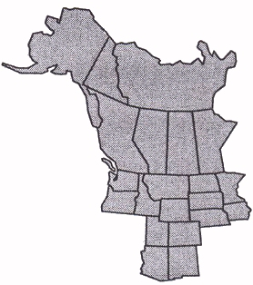

Via E-mail
Q-165

May 19, 2017

TO: All legacy Qwest Locals

FROM: Jay Boyle, Assistant to the Vice President
Susie McAllister, Administrative Director
Joe Gosiger, CWA Representative
Bargaining Committee

SUBJECT: Details of Tentative Agreement

Attached are the details of the Tentative Agreement reached between CWA and CenturyLink on May 17, 2017.
In late 2016 the Company made it clear to CWA that they wanted us to look like their non-represented units and management in regards to our Health and Welfare Benefits. They wanted us in “their” CDHP which costs more and has higher out of pocket costs and deductibles with a lower HRA. They wanted us to turn over the plan design for health care benefits to them, essentially giving up the right to bargain. The Company also indicated they wanted changes to disability, pensions, life insurance and the 401K plan.
In late March 2017 CenturyLink came to CWA and requested early, limited bargaining. The Company indicated they would like to discuss Health Care and Short Term Disability. CWA agreed to meet and told the Company we would be proposing wage increases and changes to the neutrality language in Article 1.4. Limiting the issues allowed us to preserve many of the benefits we have today.
We went to the table with the commitment that we wanted our members to be better off at the end of the Agreement or we would go to full blown bargaining in July. After negotiating with the Company we reached a Tentative Agreement. The increases in base wages are substantial and will cover the increased costs in Healthcare premiums.
The BARGAINING COMMITTEE UNANOMOUSLY RECOMMENDS RATIFICATION!
Next week we will have the contract ratification materials finalized and sent out to the Locals to conduct their ratification votes.
2.
On Monday May 22, 2017 we will host a Contract Explanation Meeting to go over the details of these documents with the Locals. There will only be 2 ports allowed per Local. Below is the call in information:
May 22, 2017
7:00PM CST, 6:00PM MST, 5:00PM PST
TN: 877 229-8493
Access code: 116327
JTB/vk opeiu30 afl-cio

Attachments

C: Staff

